Business English
Curriculum Guide
sarina molina

θωερτψυιοπασδφγηϕκλζξχϖβνμθωερτψυιοπασδφγηϕκλζξχϖβνμθωερτψυιοπασδφγηϕκλζξχϖβνμθωερτψυιοπασδφγηϕκλζξχϖβνμθωερτψυιοπασδφγηϕκλζξχϖβνμθωερτψυιοπασδφγηϕκλζξχϖβνμθωερτψυιοπασδφγηϕκτψυιοπασδφγηϕκλζξχϖβνμθωερτψυιοπασδφγηϕκλζξχϖβνμθωε

Developed for Kito International

University of San Diego
School of Leadership and Education Sciences
Department of Learning and Teaching
Teaching English to Speakers of Other Languages Program

ρτψυιοπασδφγηϕκλζξχϖβνμθωερτψυιοπασδφγηϕκλζξχϖβνμθωερτψυιοπασδφγηϕκλζξχϖβνμθωερτψυιοπασδφγηϕκλζξχϖβνμθωερτψυιοπασδφγηϕκλζξχϖβνμθωερτψυιοπασδφγηϕκλζξχϖβνμθωερτψυιοπασδφγηϕκλζξχϖβνμθωερτψυιοπασδφγηϕκλζξχϖβνμρτψυιοπασδφγηϕκλζξχϖβνμθωερτψυιοπασδφγηϕκλζξχϖβνμθωερτψυιοπασδφγηϕκλζξχϖβνμθωερτψυιοπασδφγηϕκλζξχϖβνμθωερτψυιοπασδφγηϕκλζξχϖβνμθωερτψυιοπασδφγηϕκλζξχϖβνμθωερτψυιοπασδφγηϕκλζξχϖβνμθωερτψυιοπασδφγηϕκλζξχϖβνμθωερτψυιοπασδφγηϕκλζξχϖβνμθωερτψυιοπασδφγηϕκλζξχϖβνμθωερτψυιοπασδφγηϕκλζξχϖβνμθωερτψυιοπασδφγηϕκλζξχϖβνμθωερτψυιοπασδφγηϕκλζξχϖβνμρτψυιοπασδφγηϕκλζξχϖβνμθωερτψυιοπασδφγηϕκλζξχϖβνμθωερτψυιοπασδφγηϕκλζξχϖβνμθωερτψυιοπασδφγηϕκλζξχϖβνμθωερτψυιοπασδφγηϕκλζξχϖβνμθωερτψυιοπασδφγηϕκλζξχϖβνμθωερτψυιοπασδφγηϕκλζξχϖβνμθωερτψυιοπασδφγηϕκλζξχϖβνμθωερτψυιοπασδφγηϕκλζξχϖβνμθωερτψυιοπασδφγηϕκλζξχϖβνμθωερτψυιοπασδφγηϕκλζξχϖβνμθωερτψυιοπασδφγηϕκλζξχϖβνμθωερτψυιοπασδφγηϕκλζξχϖβνμρτψυιοπασδφγηϕκλζξχϖβνμθωερτψυιοπασδφγηϕκλζξχϖβνμθωερτψυιοπασδφγηϕκλζξχϖβνμθωερτψυιοπασδφγηϕκλζξχϖβνμθωερτψυιοπασδφγηϕκλζξχϖβνμθωερτψυιοπασδφγηϕκλζξχϖβνμθωερτψυιοπασδφγηϕκλζξχϖβνμθωερτψυιοπασδφγηϕκλζξχϖβνμθωερτψυιοπασδφγηϕκλζξχϖβνμθωερτψυιοπασδφγηϕκλζξχϖβνμθωερτψυιοπασδφγηϕκλζξχϖβνμθωερτψυιοπασδφγηϕκλζξχϖβνμθωερτψυιοπασδφγηϕκλζξχϖβνμρτψυιοπασδφγηϕκλζξχϖβνμθωερτψυιοπασδφγηϕκλζξχϖβνμθωερτψυιοπασδφγηϕκλζξχϖβνμθωερτψυιοπασδφγηϕκλζξχϖβνμθωερτψυιοπασδφγηϕκλζξχϖβνμθωερτψυιοπασδφγηϕκλζξχϖβνμθωερτψυιοπασδφγηϕκλζξχϖβνμθωερτψυιοπασδφγηϕκλζξχϖβνμθωερτψυιοπασδφγηϕκλζξχϖβνμθωερτψυιοπασδφγηϕκλζξχϖβνμθωερτψυιοπασδφγηϕκλζξχϖβνμθωερτψυιοπασδφγηϕκλζξχϖβνμθωερτψυιοπασδφγηϕκλζξχϖβνμρτψυιοπασδφγηϕκλζξχϖβνμθωερτψυιοπασδφγηϕκλζξχϖβνμθωερτψυιοπασδφγηϕκλζξχϖβνμθωερτψυιοπασδφγηϕκλζξχϖβνμθωερτψυιοπασδφγηϕκλζξχϖβνμθωερτψυιοπασδφγηϕκλζξχϖβνμθωερτψυιοπασδφγηϕκλζξχϖβνμθωερτψυιοπασδφγηϕκλζξχϖβνμθωερτψυιοπασδφγηϕκλζξχϖβνμθωερτψυιοπασδφγηϕκλζξχϖβνμθωερτψυιοπασδφγηϕκλζξχϖβνμθωερτψυιοπασδφγηϕκλζξχϖβνμθωερτψυιοπασδφγηϕκλζξχϖβνμρτψυιοπασδφγηϕκλζξχϖβνμθωερτψυιοπασδφγηϕκλζξχϖβνμθωερτψυιοπασδφγηϕκλζξχϖβνμθωερτψυιοπασδφγηϕκλζξχϖβνμθωερτψυιοπασδφγηϕκλζξχϖβνμθωερτψυιοπασδφγηϕκλζξχϖβνμθωερτψυιοπασδφγηϕκλζξχϖβνμθωερτψυιοπασδφγηϕκλζξχϖβνμθωερτψυιοπασδφγηϕκλζξχϖβνμθωερτψυιοπασδφγηϕκλζξχϖβνμθωερτψυιοπασδφγηϕκλζξχϖβνμθωερτψυιοπασδφγηϕκλζξχϖβνμθωερτψυιοπασδφγηϕκλζξχϖβνμρτψυιοπασδφγηϕκλζξχϖβνμθωερτψυιοπασδφγηϕκλζξχϖβνμθωερτψυιοπασδφγηϕκλζξχϖβνμθωερτψυιοπασδφγηϕκλζξχϖβνμθωερτψυιοπασδφγηϕκλζξχϖβνμθωερτψυιοπασδφγηϕκλζξχϖβνμθωερτψυιοπασδφγηϕκλζξχϖβνμθωερτψυιοπασδφγηϕκλζξχϖβνμθωερτψυιοπασδφγηϕκλζξχϖβνμθωερτψυιοπασδφγηϕκλζξχϖβνμθωερτψυιοπασδφγηϕκλζξχϖβνμθωερτψυιοπασδφγηϕκλζξχϖβνμθωερτψυιοπασδφγηϕκλζξχϖβνμθωωερτψυιοπασδφγηϕκλζξχϖβνμθωερτψυιοπασδφγηϕκλζξχϖβνμθωερτψυιοπασδφγηϕκλζξχϖβνμθωερτψυιοπασδφγηϕκλζξχϖβνμ

LESSON 1
Writing Practice: Pre-Assessment

Welcome to our iPad English Project! We're so happy to have you on board and are looking forward to working with you. We're also interested in helping you achieve your goals and would like to support and improve your skills in English. If you have any specific areas that you're interested in having us cover over the next 8 weeks, please let us know.

For this lesson, please write an introduction of yourselves and your future goals.

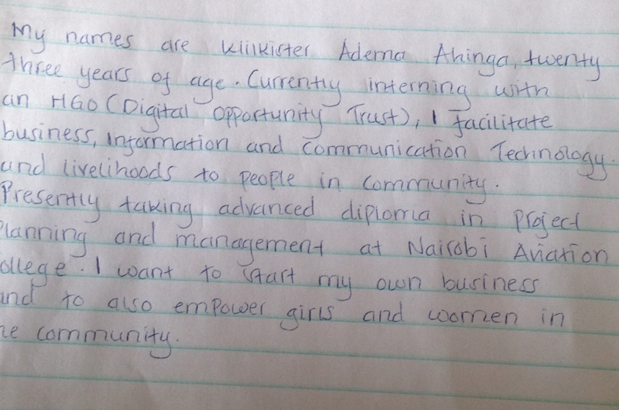

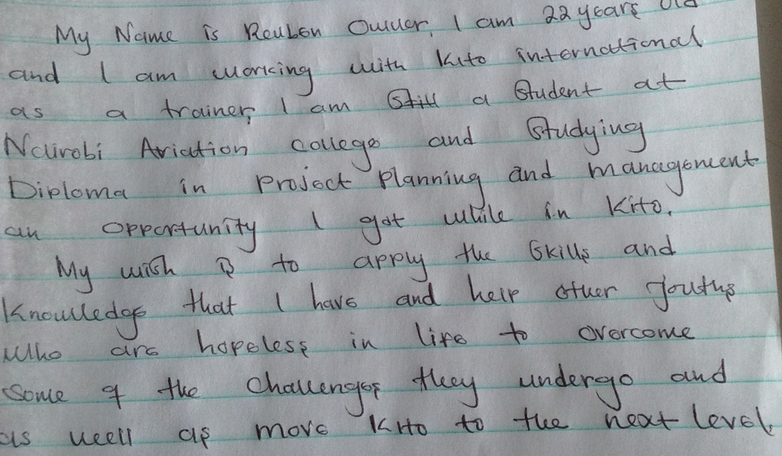

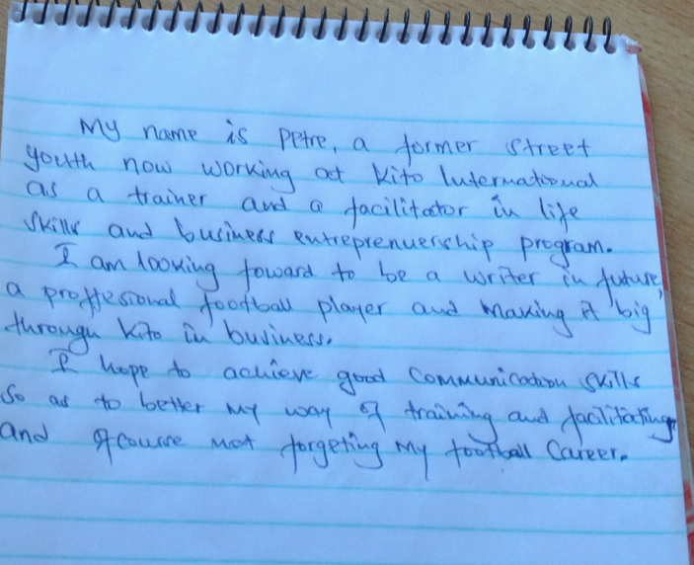

LESSON 2
Creating Introduction Videos

Please create a video introducing yourself and describe your English language needs and goals.

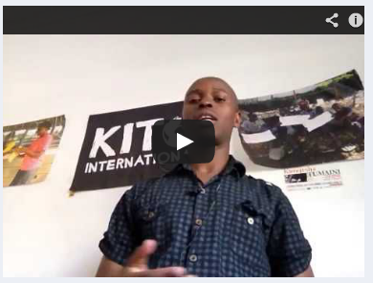

LESSON 3

Speaking Practice: Individual Asynchronous Interviews

Please complete the following:
First, view the video. Then, answer the questions from the video by making your own video, just as you did for the introduction video. Second, complete the attached survey in written form. Please post or email both your video and written survey response, which ever works best. Please let me know if there is anything can I assist you with.

1. How many languages do you speak? What are they?
2. What is your native language? How well do you feel you speak/listen/read/write in your native language?
3. How did you learn English? (e.g. school/how many years/what grades; on my own/how many years; online; friends; movies; music?)
4. How well do you feel you speak/listen/read/write in English?
5. How often do you use English in your daily life? For what purposes do you use/need English?
6. What is your position at Kito International? Can you describe your everyday routine?
7. How did you get involved with Kito International?
8. What are your short term professional goals? Please explain in detail.
9. What are your long term professional goals? Please explain in detail.
10. Are you currently working at another job or attending school? Please tell us about your other commitments outside of Kito International.
11. What products does EcoSafi produce and sell? Can you please describe each one?
12. What are some of your hobbies and interests?

Please do the following by Monday, March 11th.
1. Click on the video I attached below to watch it. Then, respond to my questions by creating a video and posting it on Edmodo. The questions are also typed in a document below entitled KI interview questions.
2. Read the 12 survey questions attached in the document below entitled Survey. Then, respond to each question by typing your answers. You can either post them on Edmodo or email them to me, whichever would be the easiest for you.
Please let me know if you have any questions!
Thanks!
Individual Interview Questions
Reuben: Interview Questions:
- You mentioned that you are currently in school at Nairobi Aviation College. Are you enjoying studying Diploma in Project Planning and Management? What do you hope to do with this knowledge after you graduate?
- You mentioned that you like to help youth who feel helpless in life overcome their many obstacles? What do you think is the best way to do this? How do you feel Kito International contributes to this issue?
- You said you would like to see Kito International “move to the next level”. What would this look like? How will you contribute to making this happen?
- As a trainer at Kito International, what do you do on a daily basis to prepare other youth to face their challenges? What are the challenges they face?
- You mentioned that you have trouble with tenses. Do you have particular tenses that you are struggling with?

Petre: Interview Questions:
- As a trainer and facilitator at Kito International, what do you do on a daily basis to prepare other youth to face their challenges? What are those challenges?
- Can you please tell me more about the business entrepreneurship program at Kito International?
- In your writing and in your video, you said it was your dream to “make it big” through Kito International and open your own business. Do you have a specific business idea you would like to pursue? How do you hope to achieve this dream/goal?
- You said that you love writing. What type of writing do you enjoy doing? How can we help you with your writing needs, particularly as it relates to helping you open your own business?
- In what ways will learning to communicate better in English help you to train other youth and improve your football career?
- You mentioned that you struggle with vocabulary. Can you share with us the type of vocabulary that you find you use inappropriately and also the kind of vocabulary you would like to develop? Would this be academic or business related vocabulary? Or vocabulary related to more of the social language?

LESSON 4
Writing a Business Letter

This week's lesson will focus on business writing. A very important aspect of writing is the use of complete sentences. Therefore, we will begin our lesson with a reading that will teach you how to identify and correct incomplete sentences. Next, you will take a quiz based on what you have learned. You will complete the quiz independently on your own Edmodo account. After the quiz, please view the video on how to write a business letter as a group. It will take approximately 15 minutes to watch. Lastly, write your own business letter to promote Kito International products. Use the video and the sample letters we have included as a reference. The due date for this assignment is Monday, March 25th. If you have any questions at all, please feel free to contact us.

2. Read the following:

SENTENCES, RUN-ONS, AND FRAGMENTS

1. A sentence has a subject and a verb and makes a complete thought. Here are a few examples of complete sentences:

- I have a pet dog. (I = subject, have = verb)
- My name is Wiclif.
- You are being very quiet today.
- He's quiet, and he's very polite. (compound sentence)

2. A fragment is only a piece of a complete thought that has been punctuated like a sentence. Here are few examples, and the fragments are underlined:

- Anne walked all alone. To the store.
- Walking to the store. She saw a car accident.
- Three years of age. Is the child.
- Because she exercises regularly. She is in good condition.

There are several ways to correct fragments. These are the three most common ways:

a) To correct a fragment, connect the fragment to a complete sentence.

"Ann walked all alone. To the store." can be corrected like this: "Ann walked all alone to the store."

"Walking to the store. She saw a car accident." can be corrected like this: "Walking to the store, she saw a car accident."

“Three years of age. Is the child.” can be corrected like this: “The child is three years of age.”

b) To correct a fragment, remove words to make the fragment a complete sentence.

"Because she exercises regularly. She is in excellent condition." can be corrected like this: "She exercises regularly. She is in excellent condition."

c) To correct a fragment, add words to make the fragment a complete sentence.

"Because she exercises regularly. She is in excellent condition." can be corrected like this: "She feels great because she exercises regularly. She is in excellent condition."

3. A run-on occurs when two sentences are run together without the proper punctuation and/or connecting words. One type of run-on occurs when two sentences are written together without any punctuation at all. Another type occurs when a comma is used between two sentences without any connecting word (such as "and, but, or, nor, for, so, yet"). Here are a few examples of run-on sentences:

Joe was happy about the raise he felt like celebrating. (This is a run-on sentence because there is no punctuation.)

Joe was happy about the raise, he felt like celebrating. (This is a run-on sentence because there is no connecting word after the comma.)

There are several ways to correct the run-on sentences above:

a) A run-on may be corrected by putting a period between the sentences.

Joe was happy about the raise. He felt like celebrating.

b) A run-on may be corrected by connecting two related sentences with a comma followed by a connecting word: and, but, or, nor, for, so, yet.

Joe was happy about the raise, so he felt like celebrating.

3. Take the quiz on Edmodo: Please work independently and submit answer from YOUR Edmodo account.

4. Watch this video on writing a business letter as a group.

“How to Write a Business Letter”
https://www.youtube.com/watch?v=egeyiUpFsaw
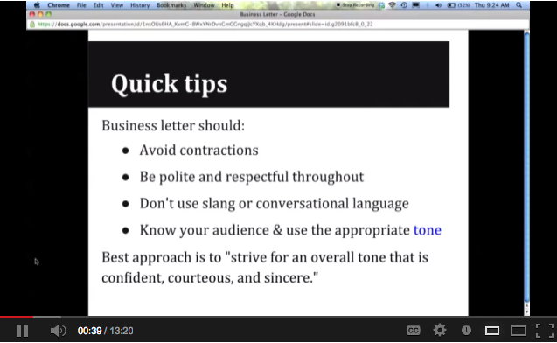
VIDEO: Click here! (Please set aside 15 minutes to watch as a group)

4. Write a business letter to share the products from Kito International to prospective buyers. (Eco Safi items) Use the video and sample letters below to draft your own. Make sure to edit your paper, and check for complete sentences. (Correct any run-ons or fragments that you find.) Here are some things to make sure your letter includes:
- the value of the products
- why someone should buy the products
- a detailed description of the products

Sample Letter #1
Sarina Molina
123 Sandy Lane
San Diego, CA 92107
U.S.A.

Dear Madam,
We are introducing our new product called “Beauty Lotion”.

It is one of the best beauty making products available in the market today. It is a famous product in many oversees markets. We are providing this to you at very low cost. Our claims are based on different feedback received from various clients and not based on self-judgment.

We humbly request you to try this item in your centers and we assure you that you will not be disappointed. Our Senior Sales associate is eager to keep in touch with you. Hope to hear from you soon.

Sincerely,

James Smith
40 Green Ave.
West Babylon, NY 11726
U.S.A.

Sample Letter #2

Marketing Director
Dymon Publications
2201 South Maple Street
Salt Lake City, UT 84797
U.S.A.

Dear Sir/Madam,

I would like to order ten (10) copies of the book, How to Introduce Yourself: A Conversation Text for ESL Students. I recently came across this book at a local teachers' conference and was very impressed by its format and contents. Could you please send the books by express mail? I need them for class next Monday. Also, would you mind sending your latest catalog or brochure?

Thank you for your prompt attention. I look forward to hearing from you soon.

Best regards,

Trent Chang

56 Somerset Lane
Kai Tak, Kowloon
Hong Kong

LESSON 5
Marketing your Products: Creating a Sales Pitch

This lesson focuses on both writing and speaking skills. The finished product will be a sales pitch from each student on one EcoSafi product. Please use the steps below to find the instructions and the links that you will need. You may watch the videos together or separately; whichever will be the easiest for you. Thank you for your hard work. We are really enjoying teaching you and look forward to seeing your videos.

Steps:
1. The grammar lesson this week focuses on independent and dependent clauses. Learning to identify and use these clauses will help you when you are trying to avoid fragments. It also will help you to use commas appropriately. Here are two resources where you can learn about these clauses. The first is a power point, and the second is a website. You can click on the links to view them and take notes to help you remember the rules later.
Review: PowerPoint 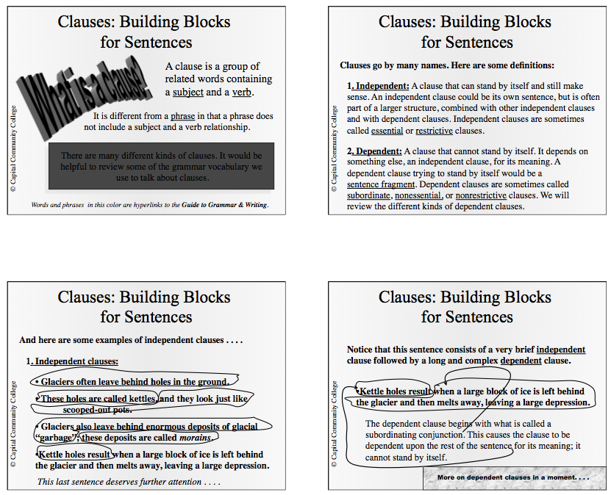
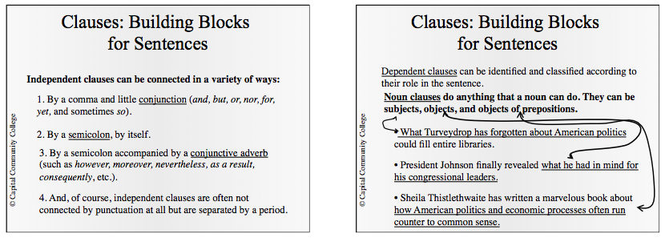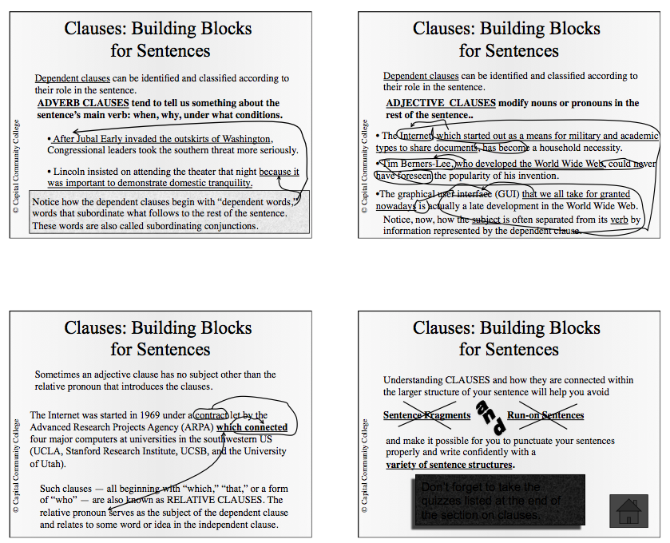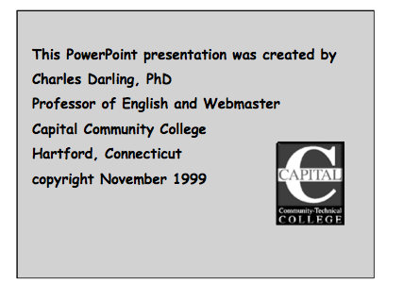

Grammar Website “Identifying Independent and Dependent Clauses”
http://owl.english.purdue.edu/owl/resource/598/01/

Welcome to the Purdue OWL
This page is brought to you by the OWL at Purdue (http://owl.english.purdue.edu/). When printing this page, you must include the entire legal notice at bottom.
Contributors:Chris Berry, Allen Brizee.
Summary:
This handout defines dependent and independent clauses and explores how they are treated in standard usage.

Identifying Independent and Dependent Clauses
When you want to use commas and semicolons in sentences and when you are concerned about whether a sentence is or is not a fragment, a good way to start is to be able to recognize dependent and independent clauses. The definitions offered here will help you with this.
Independent Clause
An independent clause is a group of words that contains a subject and verb and expresses a complete thought. An independent clause is a sentence.
Jim studied in the Sweet Shop for his chemistry quiz.
Dependent Clause
A dependent clause is a group of words that contains a subject and verb but does not express a complete thought. A dependent clause cannot be a sentence. Often a dependent clause is marked by a dependent marker word.
When Jim studied in the Sweet Shop for his chemistry quiz . . . (What happened when he studied? The thought is incomplete.)
Dependent Marker Word
A dependent marker word is a word added to the beginning of an independent clause that makes it into a dependent clause.
When Jim studied in the Sweet Shop for his chemistry quiz, it was very noisy.
Some common dependent markers are: after, although, as, as if, because, before, even if, even though, if, in order to, since, though, unless, until, whatever, when, whenever, whether, and while.
Connecting dependent and independent clauses
There are two types of words that can be used as connectors at the beginning of an independent clause: coordinating conjunctions and independent marker words.
1. Coordinating Conjunction
The seven coordinating conjunctions used as connecting words at the beginning of an independent clause are and, but, for, or, nor, so, and yet. When the second independent clause in a sentence begins with a coordinating conjunction, a comma is needed before the coordinating conjunction:
Jim studied in the Sweet Shop for his chemistry quiz, but it was hard to concentrate because of the noise.
2. Independent Marker Word
An independent marker word is a connecting word used at the beginning of an independent clause. These words can always begin a sentence that can stand alone. When the second independent clause in a sentence has an independent marker word, a semicolon is needed before the independent marker word.
Jim studied in the Sweet Shop for his chemistry quiz; however, it was hard to concentrate because of the noise.
Some common independent markers are: also, consequently, furthermore, however, moreover, nevertheless, and therefore.

Some Common Errors to Avoid
Comma Splices
A comma splice is the use of a comma between two independent clauses. You can usually fix the error by changing the comma to a period and therefore making the two clauses into two separate sentences, by changing the comma to a semicolon, or by making one clause dependent by inserting a dependent marker word in front of it.
Incorrect: I like this class, it is very interesting.
- Correct: I like this class. It is very interesting.
- (or) I like this class; it is very interesting.
- (or) I like this class, and it is very interesting.
- (or) I like this class because it is very interesting.
- (or) Because it is very interesting, I like this class.
Fused Sentences
Fused sentences happen when there are two independent clauses not separated by any form of punctuation. This error is also known as a run-on sentence. The error can sometimes be corrected by adding a period, semicolon, or colon to separate the two sentences.
Incorrect: My professor is intelligent I've learned a lot from her.
- Correct: My professor is intelligent. I've learned a lot from her.
- (or) My professor is intelligent; I've learned a lot from her.
- (or) My professor is intelligent, and I've learned a lot from her.
- (or) My professor is intelligent; moreover, I've learned a lot from her.
Sentence Fragments
Sentence fragments happen by treating a dependent clause or other incomplete thought as a complete sentence. You can usually fix this error by combining it with another sentence to make a complete thought or by removing the dependent marker.
Incorrect: Because I forgot the exam was today.
- Correct: Because I forgot the exam was today, I didn't study.
- (or) I forgot the exam was today.
Contributors:Chris Berry, Allen Brizee.
Summary:
This handout defines dependent and independent clauses and explores how they are treated in standard usage.

Run-ons - Comma Splices - Fused Sentences
Run-ons, comma splices, and fused sentences are all names given to compound sentences that are not punctuated correctly. The best way to avoid such errors is to punctuate compound sentences correctly by using one or the other of these rules.
1. Join the two independent clauses with one of the coordinating conjunctions (and, but, for, or, nor, so, yet), and use a comma before the connecting word.
_________________________, and _________________________.
He enjoys walking through the country, and he often goes backpacking on his vacations.
2. When you do not have a connecting word (or when you use a connecting word other than and, but, for, or nor, so, or yet between the two independent clauses) use a semicolon (;).
__________________________;_____________________________.
He often watched TV when there were only reruns; she preferred to read instead.
or
__________________________; however,____________________.
He often watched TV when there were only reruns; however, she preferred to read instead.
So, run-ons and fused sentences are terms describing two independent clauses which are joined together with no connecting word or punctuation to separate the clauses.
Incorrect: They weren't dangerous criminals they were detectives in disguise.
Correct: They weren't dangerous criminals; they were detectives in disguise.
Incorrect: I didn't know which job I wanted I was too confused to decide.
Correct: I didn't know which job I wanted, and I was too confused to decide.
Copyright ©1995-2013 by The Writing Lab & The OWL at Purdue and Purdue University. All rights reserved. This material may not be published, reproduced, broadcast, rewritten, or redistributed without permission. Use of this site constitutes acceptance of our terms and conditions of fair use.

2. The next part of this lesson will focus on creating a sales pitch. The first thing that you need to know is that there are several key components needed for a successful sales pitch. You will need to be sure to include these in your own video when you record it. They are:
1. An exciting first sentence or opening statement - to get the buyer’s attention
2. Information about the Product - background info, how it’s made, materials, how it can be used, where they can buy it, the cost, how to order it, why it’s different than others, etc.
3. Persuasive conclusion or ending sentence - to convince the buyer to purchase your item

3. Before you begin working on your own sales pitch, please view the video below for tips/ideas on how to sell a product using video marketing. If you feel that it would be helpful to take notes from this video since you will be creating your own sales pitch, please feel free.

Tips Video “How to Sell Using the Power of Video Marketing”
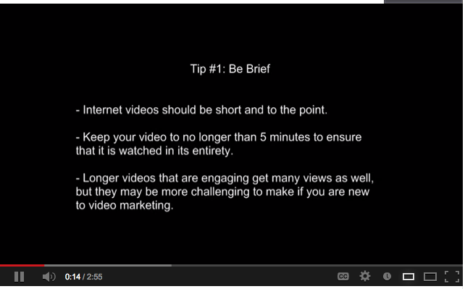
http://www.youtube.com/watch?v=cypOspeRSV8
4. Next, please view the example sales pitch video below. As you watch, identify areas of strength and weakness in this pitch and what you would do differently. Check to see if Steve Jobs used the tips that you learned in the video above to market this product. Also, see if he included the 3 key components for a sales pitch. Your observations and feedback from the video will be your quiz for this week. You will find the quiz on our Edmodo wall. Don’t forget to show your knowledge of the grammar rules we have covered thus far in your writing.
Here is the video link: Example Sales Pitch Video “Steve Jobs Presents iPad 2”
http://www.youtube.com/watch?v=SmlGA-Ld2fo
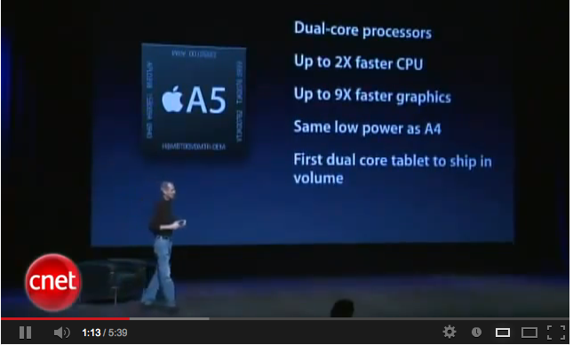

5. Since this is our first lesson that includes a speaking component, we thought it would be an excellent time to teach a pronunciation lesson. We noticed that the /th/ sound is difficult to pronounce in some English words. We hope you will find the TH practice that we have provided below useful. Please click on the website link. When you arrive at the page, scroll down and you will see two columns: one that is labeled soft TH, and one that is labeled hard TH. Click on the blue video link under the soft TH column, and follow along with the video while practicing saying the words listed in that column. When you have completed the soft TH drill, do the same with the hard TH sound video in the right column. TH Practice Website: http://www.speakmethod.com/English%20Pronunciation%20TH%20sounds.html
Watch: http://www.speakmethod.com/video500wordsTHintro
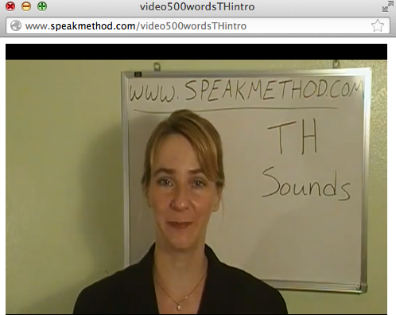
6. Project: Choose ONE product from Ecosafi, and create a sales pitch to market this product. Use the Ipad to develop a video and post it on our Edmodo wall. The assignment should be done individually and everyone should choose a different product. Remember to use the tips you have learned from the video and include the 3 key components of a sales pitch in your video. (Review: 1. An exciting first sentence or opening statement - to get the buyer’s attention 2. Information about the Product - background info, how it’s made, materials, how it can be used, where you can buy it, the cost, how to order it, etc. 3. Persuasive conclusion or ending sentence to convince the buyer to purchase)
It is also a great idea to write down your pitch, like a speech, so that you will remember to include everything you want to say. You can also show the actual product in your sales pitch, so that the prospective buyer will have a visual to look at as you speak. Choose the options that will work best for you. As always, if you have any questions or concerns, please contact us. We are excited to see your sales pitch videos!

Please refer to this week's lesson before completing this quiz. To answer these quiz questions, you will need to watch the example sales pitch video and identify strengths, weaknesses, and what you would do differently in your own sales pitch. Also, when writing your answers, remember to include what you have learned from all the grammar lessons we have provided in this program thus far. This includes checking your writing for fragments, run ons, proper verb conjugation, and independent and dependent clauses. As always, we encourage you to ask us any questions that you may have before you begin. Thanks for your had work, and good luck!

Quiz

LESSON 6

Researching Potential Employers
Thank you for posting your sales pitch videos. We are very excited to view them, and will provide feedback soon.
This week's assignment will give you the opportunity to research a company of your choosing. Please pick one company that you would potentially be interested in working for in the near future. Before you begin, we have provided an article and short video for you to watch that will help to guide you in your research. You will find all the links and directions in the file attached below. We ask that you submit the answers to the 10 questions based on your research by next Monday, April 29th. We know that his lesson requires the use of more internet than our other lessons, so please keep us updated on your progress. As always, if you have any questions or concerns, please do not hesitate to let us know. We hope you have fun researching!

This week’s lesson is on how to research companies for future employment opportunities. Doing your research on a company or school, prior to an interview, can determine if you will get hired or not. Dr. Molina shared that she is always impressed when she interviews students that have done their research about the school and the specific program that she is in charge of. The same goes for employers. This week you will get the opportunity to practice the skill of researching. We also have provided an article for you to read, and video for you to view, on how to become an effective job hunter. You should read and view these resources before you begin the assignment.

Read Article: “Step-by-Step Guide to Researching Companies:
How to Conduct Job-Search Research” by Randall S. Hansen, Ph.D.
http://www.quintcareers.com/researching_companies_guide.html
One of the most important skills a job-seeker can learn during a job-search is research skills. The quality of your research skills may make or break your job search. So, make the commitment to improve your research skills. You'll find that that research skills will not only help you in searching for a new job, but will come in handy in many other situations in the future.
Information is a critical commodity in job-hunting; the more you know and the easier it is for you to find information, the better your chances of success. Employers value job-seekers who know key information about the company because that knowledge demonstrates your interest and enthusiasm for the company and for the job. This article will take you on a short journey through the basic steps in conducting company research.
Step 1: When to Do Research
For most job-seekers, there are three critical times to conduct research. The first is when you are just starting your job-search and looking to identify key companies in your profession or industry, or even in a specific geographic location. The second possibility is when you are applying to an employer; it's always best to relate yourself to the company and tailor your cover letter and resume to each employer. The third -- and when most job-seekers finally do some research -- is when you have been invited to a job interview; you'll want to showcase your knowledge of the company.
The sooner you get started, the better off you'll be.
Step 2: Determine What Information You Want
You are usually seeking two sets of information.
The first set of information deals with general company information. The types of information you might gather here include: products and services, history and corporate culture, organizational mission and goals, key financial statistics, organizational structure (divisions, subsidiaries, etc.), and locations (main and branch).
The second set of information deals with employment issues, and includes such things as career paths and advancement opportunities, benefits, diversity initiatives, and other human resources functions.
Of course, you may also research the industry, key competitors, and countries where the company has offices.
Step 3: Short Cuts/Starting Points
If you really have no idea of what companies might be best for you, there are some good places to start. A number of media have already done the research for you - and have produced various "best" lists. . . best companies for women, best private companies, best employee-owned companies, etc.
Go to our The Best Companies for Job-Seekers section to take advantage of these short cuts.
Step 4: Where to Find Company Information
Probably the single best resource of company information is the company's Website. You can find the company site by trying to type the company name in your browser. For example, if you were trying to find information on Aetna, all you need to do is enter www.aetna.com and you're at the company's Website. However, not all companies have such obvious Web addresses, so the next easiest thing to do is go to your favorite search engine, such as Google.com, and type the company's name in the search box. Then simply follow the link to the company's Website.
Sometimes the information you'll find on a company's Website is limited. While the trend is certainly for companies to place more and more information on their sites, private companies (not traded on any stock exchange) tend to have less need to provide sensitive information. What can you do in these situations? The next best solution is to read outside reviews and profiles of companies.
Among the two best sources for gathering information on public companies are BusinessWeek Online: Company Research and Hoovers Online.
Finding information about private companies -- and the vast majority of all companies in the U.S. are private -- is a bit trickier. Two good sources are the Forbes Largest Private Companies list and The Inc. 500 list of America's fastest growing privately-held companies.
If you are interested in working for a non-profit organization or association, the best research tools to use include the resources we provide in our Volunteering and Non-Profit Career Resources and General Professional Organizations and Associations.
Another great source of company information comes from articles and stories published in various media outlets. There are literally thousands of media outlets, from national news and business publications to specialized industry-specific publications. A good source for finding media that cover your industry is NewsLink.
One other tool we've developed here at Quintessential Careers is the Quintessential Directory of Company Career Centers. You'll find several hundred companies, organized alphabetically, as well as by rankings.
Find more resources in our Guide to Researching Companies, Industries, and Countries.
Step 5: Getting Industry Information
The next level of sophistication in conducting research is getting a handle on the competitive nature of the industry (or industries) that your list of companies operate within. It is within the competitive environment that you might be able to spot trends that are either opportunities or threats for your prospective employers.
One good source of industry information is Industry Portals, a listing of links to many different industries.
The best print source is a U.S. government publication: U.S. Industrial Outlook, from the Bureau of Industrial Economics.
Find more resources in our Guide to Researching Companies, Industries, and Countries.
Step 6: Gathering Country and Place-of-Living Information
The final step in your research process may be to gather information about specific parts of the U.S. or other countries -- to help you decide if you want to relocate to where a prospective employer is located.
For conducting research within the U.S., we recommend Sperling's BestPlaces.net, where you'll find a wealth of data, statistics, and comparisons about U.S. cities and counties.
For developing a better understanding of locations outside the U.S, we recommend the CIA World Factbook, which contains detailed snapshots, compiled by the U.S. government, of just about every country in the world.
Find more resources in our Guide to Researching Companies, Industries, and Countries.
Questions about some of the terminology used in this article? Get more information (definitions and links) on key college, career, and job-search terms by going to our Job-Seeker's Glossary of Job-Hunting Terms.
Dr. Randall S. Hansen is founder of Quintessential Careers, one of the oldest and most comprehensive career development sites on the Web, as well CEO of EmpoweringSites.com. He is also founder of MyCollegeSuccessStory.com and EnhanceMyVocabulary.com. He is publisher of Quintessential Careers Press, including the Quintessential Careers electronic newsletter, QuintZine. Dr. Hansen is also a published author, with several books, chapters in books, and hundreds of articles. He's often quoted in the media and conducts empowering workshops around the country. Finally, Dr. Hansen is also an educator, having taught at the college level for more than 15 years. Visit his personal Website or reach him by email at randall(at)quintcareers.com.

Watch Youtube Video: “7 Tips for Researching Companies”
https://www.youtube.com/watch?v=hYc2MEJaFxw
Please complete the guidelines below on researching a potential company that you wish to work with for in the future. By completing this list of questions, we will have a better understanding of your career goals, and next week you will be able to develop a thorough resume that can be used when you apply for future jobs. As always, we are here to support your learning. If you have any questions, please contact us. Also, there will no quiz this week, since you will be researching and then answering several questions.

Please remember to use complete sentences when answering the questions below.
For example: Question #1: What company did you choose?

Answer #1: I chose to research Kito International.

First, research a company for which you would like to work (within Kenya). Then, complete the following questionnaire:

1. What company did you choose?
2. What are two reasons why you chose this company?
3. What is the goal or mission of this company?
4. What does this company do to achieve their mission?
5. Pick 1 or 2 positions that are available at this job. What do these two positions entail? (What is expected of the worker in that position?)
6. What qualifications are required for those positions?
7. Pick one of the two positions and tell why you would be a good fit for this position. How do you fit the needs of the position?
8. What are two ways in which you can improve to meet the needs of the position?
(examples: knowledge of products, education, experience, etc.)
9. Come up with two questions for the employer that you would like to find out about the job or company.
10. How would this company/job help you meet your short term AND long term career goals?

LESSON 7

Writing your Résumé

Thank you for submitting your research assignments. We have two more modules to go! This week, we would like you to take your learning form researching the organization of your interest and market yourself by creating a resume. You will have until next Tuesday, May 14th to submit your resumes to us. Once your resumes are submitted, we will proceed to setting up a time to do a live skype mock interview with each of you. It should be a very exciting project!

Lesson: Writing your Résumé

Dear Kito Staff Members and Business English students,

We are getting to the end of our program together with only 2 more lessons left. This week, we will have you take your research and create a résumé that highlights your education, experience, and skills.

1) View Resume Writing Tutorial “Resume Writing Tips, How To Write a Creative Resume & Get a Job by Michelle, WriteByNight”

on Youtube http://www.youtube.com/watch?v=-OrqzS-Qbf8

2) Create your own Résumé

a) Open templates in Word and search “resume”

b) Select any resume template of your choice

c) Fill in the resume template with your information.

••• Examples of resumes can be found on the following sites:
Sample 1
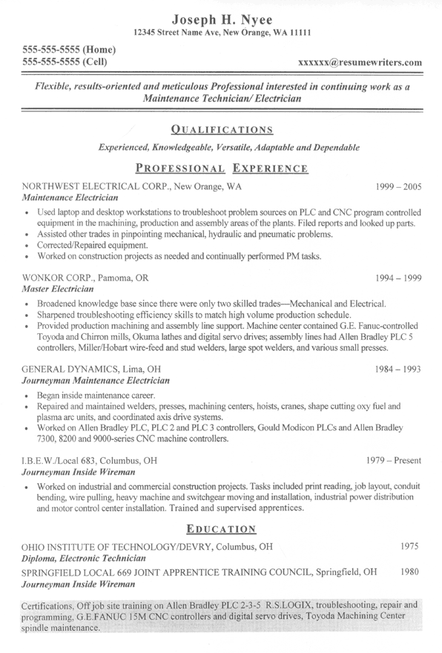

Sample 2

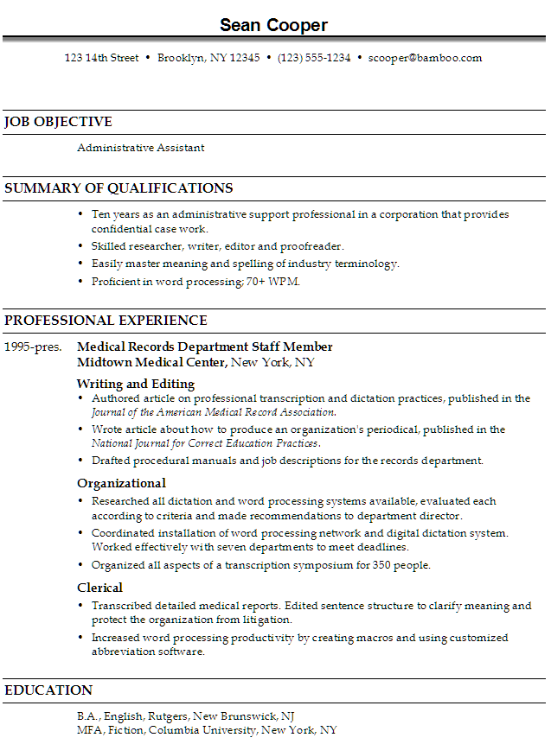

Due: May 14th, 2013

LESSON 8

PREPARING FOR A JOB INTERVIEW

For our last lesson, we have compiled several resources and attached them below. Please utilize them as you prepare for your mock-job interview via Skype next week. You may want to take notes as you watch “6 Tips to Ace a Job Interview” and read the article. You also will need to brainstorm and jot down some ideas of questions to ask during your interview. (Imagine you were really interviewing for the position that you researched - What would you want to know?) Please let us know if you have any questions. We truly appreciate your continued dedication to this project.

Watch: “6 Tips to Ace a Job Interview” on Youtube 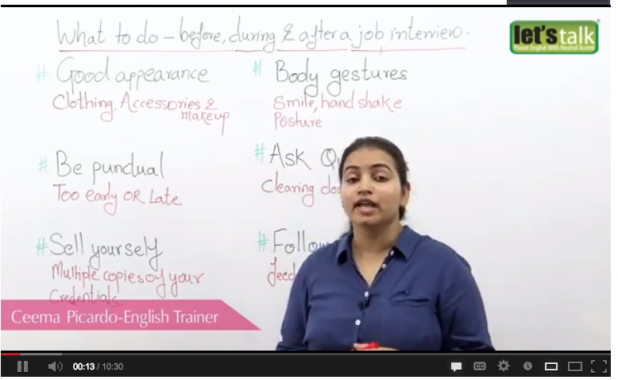

Read “How to Answer 23 of the Most Common Interview Questions”

http://www.wisebread.com/how-to-answer-23-of-the-most-common-interview-questions

[Editor's note: If you recently lost your job, take a look at Wise Bread's collection of tips and resources for the recently laid off.]
Let's face it; no one likes the interview process. Well, certainly not the people being interviewed anyway. You have to be on your best behavior, you only get one chance to get it right, and it's like taking your driving test all over again. Over the years I've been to countless interviews. To get my first job out of college I attended some 15-20 interviews a week. Whether it was in Britain or over here in the States, the questions never really seemed to change from job to job. Not only that, but the answers to them are usually the same, with your own personal interpretation of course. Here I present 23 questions you're likely to be asked, and how I have learned to answer them. Why 23? Because I had more than 20 and less than 25. Remember, being interviewed is a skill, and if you do the preparation you should ace it every time. (See also: Error! Hyperlink reference not valid.)
1. So, tell me a little about yourself.
I'd be very surprised if you haven't been asked this one at every interview. It's probably the most asked question because it sets the stage for the interview and it gets you talking. Be careful not to give the interviewer your life story here. You don't need to explain everything from birth to present day. Relevant facts about education, your career and your current life situation are fine.
2. Why are you looking (or why did you leave you last job)?
This should be a straightforward question to answer, but it can trip you up. Presumably you are looking for a new job (or any job) because you want to advance your career and get a position that allows you to grow as a person and an employee. It's not a good idea to mention money here, it can make you sound mercenary. And if you are in the unfortunate situation of having been downsized, stay positive and be as brief as possible about it. If you were fired, you'll need a good explanation. But once again, stay positive.
3. Tell me what you know about this company.
Do your homework before you go to any interview. Whether it's being the VP of marketing or the mailroom clerk, you should know about the company or business you're going to work for. Has this company been in the news lately? Who are the people in the company you should know about? Do the background work, it will make you stand out as someone who comes prepared, and is genuinely interested in the company and the job.
4. Why do you want to work at X Company?
This should be directly related to the last question. Any research you've done on the company should have led you to the conclusion that you'd want to work there. After all, you're at the interview, right? Put some thought into this answer before you have your interview, mention your career goals and highlight forward-thinking goals and career plans.
5. What relevant experience do you have?
Hopefully if you're applying for this position you have bags of related experience, and if that's the case you should mention it all. But if you're switching careers or trying something a little different, your experience may initially not look like it's matching up. That's when you need a little honest creativity to match the experiences required with the ones you have. People skills are people skills after all, you just need to show how customer service skills can apply to internal management positions, and so on.
6. If your previous co-workers were here, what would they say about you?
Ok, this is not the time for full disclosure. If some people from your past are going to say you're a boring A-hole, you don't need to bring that up. Stay positive, always, and maybe have a few specific quotes in mind. "They'd say I was a hard worker" or even better "John Doe has always said I was the most reliable, creative problem-solver he'd ever met."
7. Have you done anything to further your experience?
This could include anything from night classes to hobbies and sports. If it's related, it's worth mentioning. Obviously anything to do with further education is great, but maybe you're spending time on a home improvement project to work on skills such as self-sufficiency, time management and motivation.
8. Where else have you applied?
This is a good way to hint that you're in demand, without sounding like you're whoring yourself all over town. So, be honest and mention a few other companies but don't go into detail. The fact that you're seriously looking and keeping your options open is what the interviewer is driving at.

9. How are you when you're working under pressure?
Once again, there are a few ways to answer this but they should all be positive. You may work well under pressure, you may thrive under pressure, and you may actually PREFER working under pressure. If you say you crumble like aged blue cheese, this is not going to help you get your foot in the door.
10. What motivates you to do a good job?
The answer to this one is not money, even if it is. You should be motivated by life's noble pursuits. You want recognition for a job well done. You want to become better at your job. You want to help others or be a leader in your field.
11. What's your greatest strength?
This is your chance to shine. You're being asked to explain why you are a great employee, so don't hold back and stay do stay positive. You could be someone who thrives under pressure, a great motivator, an amazing problem solver or someone with extraordinary attention to detail. If your greatest strength, however, is to drink anyone under the table or get a top score on Mario Kart, keep it to yourself. The interviewer is looking for work-related strengths.
12. What's your biggest weakness?
If you're completely honest, you may be kicking yourself in the butt. If you say you don't have one, you're obviously lying. This is a horrible question and one that politicians have become masters at answering. They say things like "I'm perhaps too committed to my work and don't spend enough time with my family." Oh, there's a fireable offense. I've even heard "I think I'm too good at my job, it can often make people jealous." Please, let's keep our feet on the ground. If you're asked this question, give a small, work-related flaw that you're working hard to improve. Example: "I've been told I occasionally focus on details and miss the bigger picture, so I've been spending time laying out the complete project every day to see my overall progress."
13. Let's talk about salary. What are you looking for?
Run for cover! This is one tricky game to play in an interview. Even if you know the salary range for the job, if you answer first you're already showing all your cards. You want as much as possible, the employer wants you for as little as you're willing to take. Before you apply, take a look at salary.com for a good idea of what someone with your specific experience should be paid. You may want to say, "well, that's something I've thought long and hard about and I think someone with my experience should get between X & Y." Or, you could be sly and say, "right now, I'm more interested in talking more about what the position can offer my career." That could at least buy you a little time to scope out the situation. But if you do have a specific figure in mind and you are confident that you can get it, I'd say go for it. I have on many occasions, and every time I got very close to that figure (both below and sometimes above).
14. Are you good at working in a team?
Unless you have the I.Q. of a houseplant, you'll always answer YES to this one. It's the only answer. How can anyone function inside an organization if they are a loner? You may want to mention what part you like to play in a team though; it's a great chance to explain that you're a natural leader.
15. Tell me a suggestion you have made that was implemented.
It's important here to focus on the word "implemented." There's nothing wrong with having a thousand great ideas, but if the only place they live is on your notepad what's the point? Better still, you need a good ending. If your previous company took your advice and ended up going bankrupt, that's not such a great example either. Be prepared with a story about an idea of yours that was taken from idea to implementation, and considered successful.
16. Has anything ever irritated you about people you've worked with?
Of course, you have a list as long as your arm. But you can't say that, it shows you as being negative and difficult to work with. The best way to answer this one is to think for a while and then say something like "I've always got on just fine with my co-workers actually."
17. Is there anyone you just could not work with?
No. Well, unless you're talking about murderers, racists, rapists, thieves or other dastardly characters, you can work with anyone. Otherwise you could be flagged as someone who's picky and difficult if you say, "I can't work with anyone who's a Bronco's fan. Sorry."
18. Tell me about any issues you've had with a previous boss.
Arrgh! If you fall for this one you shouldn't be hired anyway. The interviewer is testing you to see if you'll speak badly about your previous supervisor. Simply answer this question with extreme tact, diplomacy and if necessary, a big fat loss of memory. In short, you've never had any issues.
19. Would you rather work for money or job satisfaction?
It's not a very fair question is it? We'd all love to get paid a Trump-like salary doing a job we love but that's rare indeed. It's fine to say money is important, but remember that NOTHING is more important to you than the job. Otherwise, you're just someone looking for a bigger paycheck.
20. Would you rather be liked or feared?
I have been asked this a lot, in various incarnations. The first time I just drew a blank and said, "I don't know." That went over badly, but it was right at the start of my career when I had little to no experience. Since then I've realized that my genuine answer is "Neither, I'd rather be respected." You don't want to be feared because fear is no way to motivate a team. You may got the job done but at what cost? Similarly, if you're everyone's best friend you'll find it difficult to make tough decisions or hit deadlines. But when you're respected, you don't have to be a complete bastard or a lame duck to get the job done.
21. Are you willing to put the interests of X Company ahead of your own?
Again, another nasty question. If you say yes, you're a corporate whore who doesn't care about family. If you say no, you're disloyal to the company. I'm afraid that you'll probably have to say yes to this one though, because you're trying to be the perfect employee at this point, and perfect employees don't cut out early for Jimmy's baseball game.
22. So, explain why I should hire you.
As I'm sure you know, "because I'm great" or "I really need a job" are not good answers here. This is a time to give the employer a laundry list of your greatest talents that just so happen to match the job description. It's also good to avoid taking potshots at other potential candidates here. Focus on yourself and your talents, not other people's flaws.
23. Finally, do you have any questions to ask me?
I'll finish the way I started, with one of the most common questions asked in interviews. This directly relates to the research you've done on the company and also gives you a chance to show how eager and prepared you are. You'll probably want to ask about benefits if they haven't been covered already. A good generic one is "how soon could I start, if I were offered the job of course." You may also ask what you'd be working on. Specifically, in the role you're applying for and how that affects the rest of the company. Always have questions ready, greeting this one with a blank stare is a rotten way to finish your interview. Good luck and happy job hunting.

